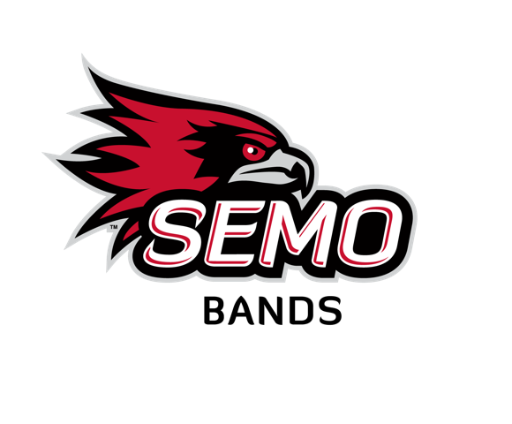
SUMMER BAND CAMP PACKING LIST
MIDDLE SCHOOL & HIGH SCHOOL CAMPS

Instrument
___Instrument and case (name on case)
___ Extra reeds
___ Slide grease/valve oil
___ Pencil
___ Audition Music

THEME DAYS
Sunday – School Shirt
Monday – Hawaiian Shirt
Tuesday – Red and Black
Wednesday – Barbie Day!
Thursday – Band Camp Shirt
Bedding
___Sheets or Sleeping Bag (the beds are twin)
___ Blanket
___ Pillow

Bathroom
___ Towels
___ Wash clothes I
___Toothbrush
___ Toothpaste
___ Deodorant
___ Shampoo
___ Hairbrush
___ Eyeglasses/Contacts
___ Solution
___ Soap
___ Q-tips
___ Shaving Cream
___ Razor
___ Band Aids
___ Tweezers
___ Feminine Products
___ Make-up

Clothing
___ Shorts or pants for each day
___ Shirts – there are theme days if you would like to participate
___ Undergarments and socks
___ Sleep clothes
___ Comfortable walking shoes
___ Swimsuit (not all camps)
___ Concert Dress clothes (camp shirt and black or khaki shorts)

Other Items
___ Cell Phones are allowed, but must be off during classes, assemblies, and other camp functions
___ Charger as needed
___ Refillable water bottle (there is a water bottle refill station)

DO NOT BRING: no tobacco and/or vape products, alcohol, fireworks, skateboards, rollerblades, roller shoes, hoverboards, or laser pointers.

Dress Code: Typical school clothing. Shorts are permitted. SEMO building regulations require that shoes be worn in all campus buildings.

